 | 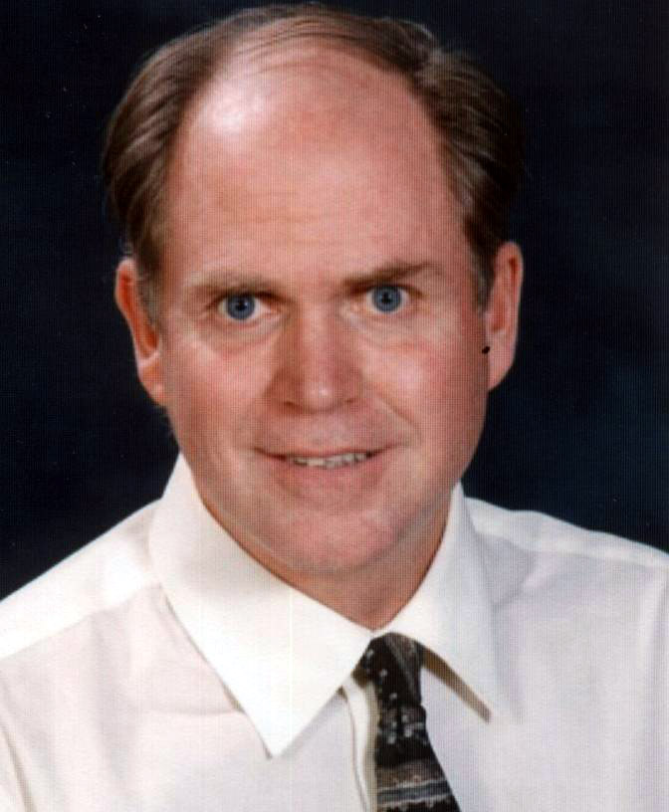 | James W. Burwell
Escazú, San José, Costa Rica
Cell: 00-506-8789-3808 / Work: 00-506-2289-0919
jim_burwell@hotmail.com http://jimb.webnode.com/edu/
 | Professional Goals
- To serve as a high school or middle school administrator, English/language arts teacher, and/or social studies teacher at a premiere international school looking for an instructional leader with experience in the United States and abroad
- To continue to grow as a life-long learner and an educator in bringing innovative thinking and best practices to a school community
- To participate as a team player with school faculty, administration, community, and students in order to create a collaborative learning environment for the purpose of high standards in student learning
 | Degrees and Certification
 |  | Michigan State University
 |  | Master of Arts in K-12 Educational Administration: August 2009
 |  | Western Washington University
 |  | Bachelor of Arts in Education: June, 1983
 |  | Washington State Teaching Certification
 |  | Grades 6-12 with endorsements in English and Social Studies
 | Professional Awards
 |  | - Innovative Teacher of the Year Award, Country Day High School, 2010-2011 School Year
 |  | - Outstanding Character Award, Awarded by NHS Students at Colegio Interamericano, 2007-2008 School Year

 |  | - Teacher Leadership Project: Awarded a grant from the Bill and Melinda Gates Foundation for $10,000 worth of technology in the classroom and 15 credits of instruction on the integration of technology into the classroom, 1999-2001
 |  | - National Endowment for the Humanities: Awarded a grant for experiential instructional strategies concerning holocaust studies, 2001
 |  | - National Consortium for Teaching about Asia and the East Asia Resource Center: Awarded a grant for the integration of Asian studies in to the humanities classroom, 2002
 |  | - Awarded local grants in Anacortes, WA for the integration of art into the classroom, 2001-2002
Related Experience
 | 8/10-Present | Grade 12/AP English Teacher, Country Day School, Costa Rica  Teach grade 12 British Literature, Creative Writing, and AP English Literature. In addition, serve as Student Council advisor and 12th Grade Faculty Advisor
 | 6/07-6/10 | High School Principal, Colegio Interamericano, Guatemala  Directed high school of 300 students, grades 9-12, including curriculum design and improvements, faculty evaluation and training, activities coordination, and more
 | 8/05-6/07 | English Teacher 10th Grade, Colegio Interamericano, Guatemala  Additional responsibilities included English Department Head, Debate Coach, and Knowledge Bowl Coach
 | 9/98-6/03 | Social Studies/English Teacher, Debate Coach, Anacortes High School,  Subjects included Pacific Rim/Technology, U.S. History, World History, 9th Grade English, and Debate. Additional responsibilities included serving on School Improvement Council, School Community Council, and Rules Committee
 | 1/98-6/98 | 9th Grade Social Studies/English Block Teacher, Klahowya Secondary School  Taught Washington State History, Language Arts, and Service Learning. Non-continuing contract
 | 1/97-10/97 | Social Studies/English Teacher, American School of Guatemala  Subjects included Honor’s Social Studies (Grade 12), Health (Grade 9), and Public Speaking (Grade 10)
 | 1/84-10/85 | Social Studies Teacher, American School of Guatemala  Subjects included World Geography (Grade 8), World History (Grade 9), United States History (Grade 10), Senior Social Studies (Grade 12), and English (Grade 8). Also coached Debate and advised Student Government.
Additional Experience
 | 1/93-10/96 | Herb Project, San Buenaventura de Atitlán, Panajachel, Guatemala  Developed medicinal, culinary, and aromatic herb botanical garden at the Nature Reserve “San Buenaventura de Atitlán”
 | 1/93-10/96 | Asociacion Ija’tz, San Lucas Tolimán, Guatemala  Worked as a consultant with local farmers to develop an organic farm and educational program, and center of Permaculture
 | 8/87-11/92 | Bainbridge Island Park District Bainbridge Island, WA; Assistant Pool Manager  Supervised operations of large municipal swimming pool.
 | 5/78-9/83 | Kitsap Golf & Country Club, Bremerton, WA; Swimming Pool Manager  Supervised program and operations of outdoor seasonal swimming pool, including personnel, swim lesson program, and maintenance.
Professional Learning Workshops Conducted
 | Sept., 2011 | Using Wikispaces and Glogster for Web-based Portfolios
 | April,  2011 | Edline and the Paperless Classroom
 | March,  2011 | Wikispaces for Teaching Student Writing
 | Feb.,  2010 | Integrating Marzano’s What Works in Schools and Tomlinson’s Differentiated Instruction
 | Mar.,  2010 | Unit Planning using Wiggins’ Understanding by Design
 | Oct.,  2006 | 6 Trait Writing For All Grade Levels
 | April.,  2006 | Assessment and the Use of Rubrics
 | Oct., 2005 | Teaching Strategies for a Block Schedule
Personal
 |  | Health: Excellent |  | Citizenship: United States
 |  | Marital Status: Single |  | Date of Birth: June 1, 1961
Professional References
While at Country Day School
300m oeste, 300m sur del Banco Nacional; Escazú Centro, San José, Costa Rica

Chris Brown | Greg MacGilpin | Joshua Knudson | Douglas Gamble
High School Principal | General Director | Coordinator for Educational Technology | High School English Teacher
See Letter  christopher_brown@cds.ed.cr | greg_macgilpin@cds.ed.cr | See Letter  joshua_knudson@cds.ed.cr | See Letter  douglas_gamble@cds.ed.cr
00-506-2289-0919 | 00-506-2289-0919 | 00-506-2289-0919 | 00-506-2289-0919

While at Colegio Interamericano  Boulevard La Montaña, Finca El Socorro, Zona 16; Guatemala City, Guatemala |  |  |  |  | While at Anacortes High School  Anacortes, WA, U.S.A
Dr. Michael Farr | Olga Renata de Alejos | Luis Masaya | Keith Rittel
Former General Director  Retired | Former Director of Curriculum  Now General Director,  Colegio Monarch, Guatemala City, Guatemala | High School Technology Teacher | Former High School Principal  Now Deputy Superintendent Clover Park School District,  Lakewood, WA
See Letter | See Letter | See Letter | See Letter
robertmfarr@msn.com | oralejos@colegiomonarch.com | masayalorenzana@gmail.com | krittel@cloverpark.k12.wa.us
 |  | 00-502-5313-0030 | 001-253-583-5051

While at American School of Guatemala
11 calle 15-79 Zona 15 Vista Hermosa III; Guatemala City, Guatemala
Barbara Barillas | Maria Hirst | Kim Pivaral
Former General Director  Retired | Former High School Principal  Now Curriculum Coordinator | Former English Teacher and Department Head  Now Public Relations Coordinator
See Letter | See Letter | See Letter
bbbabm@yahoo.coma | mhirst@cag.edu.gt | kpivaral@cag.edu.gt
 | 00-502-2369-0791 | 00-502-2369-0791

